**Advancing Social Equity and Inclusive Growth**

**Dr. Syed Nazim Ali**

Director Research Division, College of Islamic Studies

Director, Center for Islamic Economics and Finance HBKU –Qatar

15 –16 December, Tlemcen

In today’s dynamic global economy, where challenges of inequality and exclusion persist, there is an urgent need to seek ethical and innovative pathways for inclusive growth. Islamic finance, with its intrinsic principles of justice, fairness, and shared prosperity, offers a framework that aligns with these aspirations and holds immense potential to address global disparities effectively.

In this keynote address, I seek to explore how Islamic finance can redefine global financial systems through its focus on social equity and moral governance. By extending its reach to underserved communities, it offers a model that is not just economically sustainable but also rooted in values that emphasize the welfare of all.

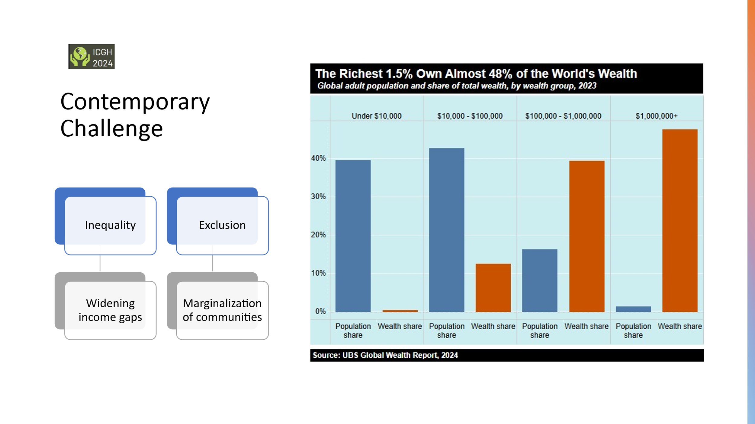

**Contemporary Challenges**

As we have seen, wider income gaps are happening and the uneven distribution of wealth and resources among individuals or groups within a society has been observed especially disparity between the rich and poor. This can lead to social unrest, reduced economic mobility, and weakened social cohesion. It often perpetuates cycles of poverty and limits access to opportunities for disadvantaged groups.

In the today’s economy and financial system these communities in a way systematically isolated or some of them are neglected – preventing them from participating fully in social, economics and political life. The marginalized communities are sometime the victim of ethnicity, religion, gender. This inequity prevent them access to essential resources, opportunities, and representation, often leading to social alienation and economic stagnation.

Addressing these issues requires comprehensive strategies to promote inclusivity, equitable resource distribution, and opportunities for all.

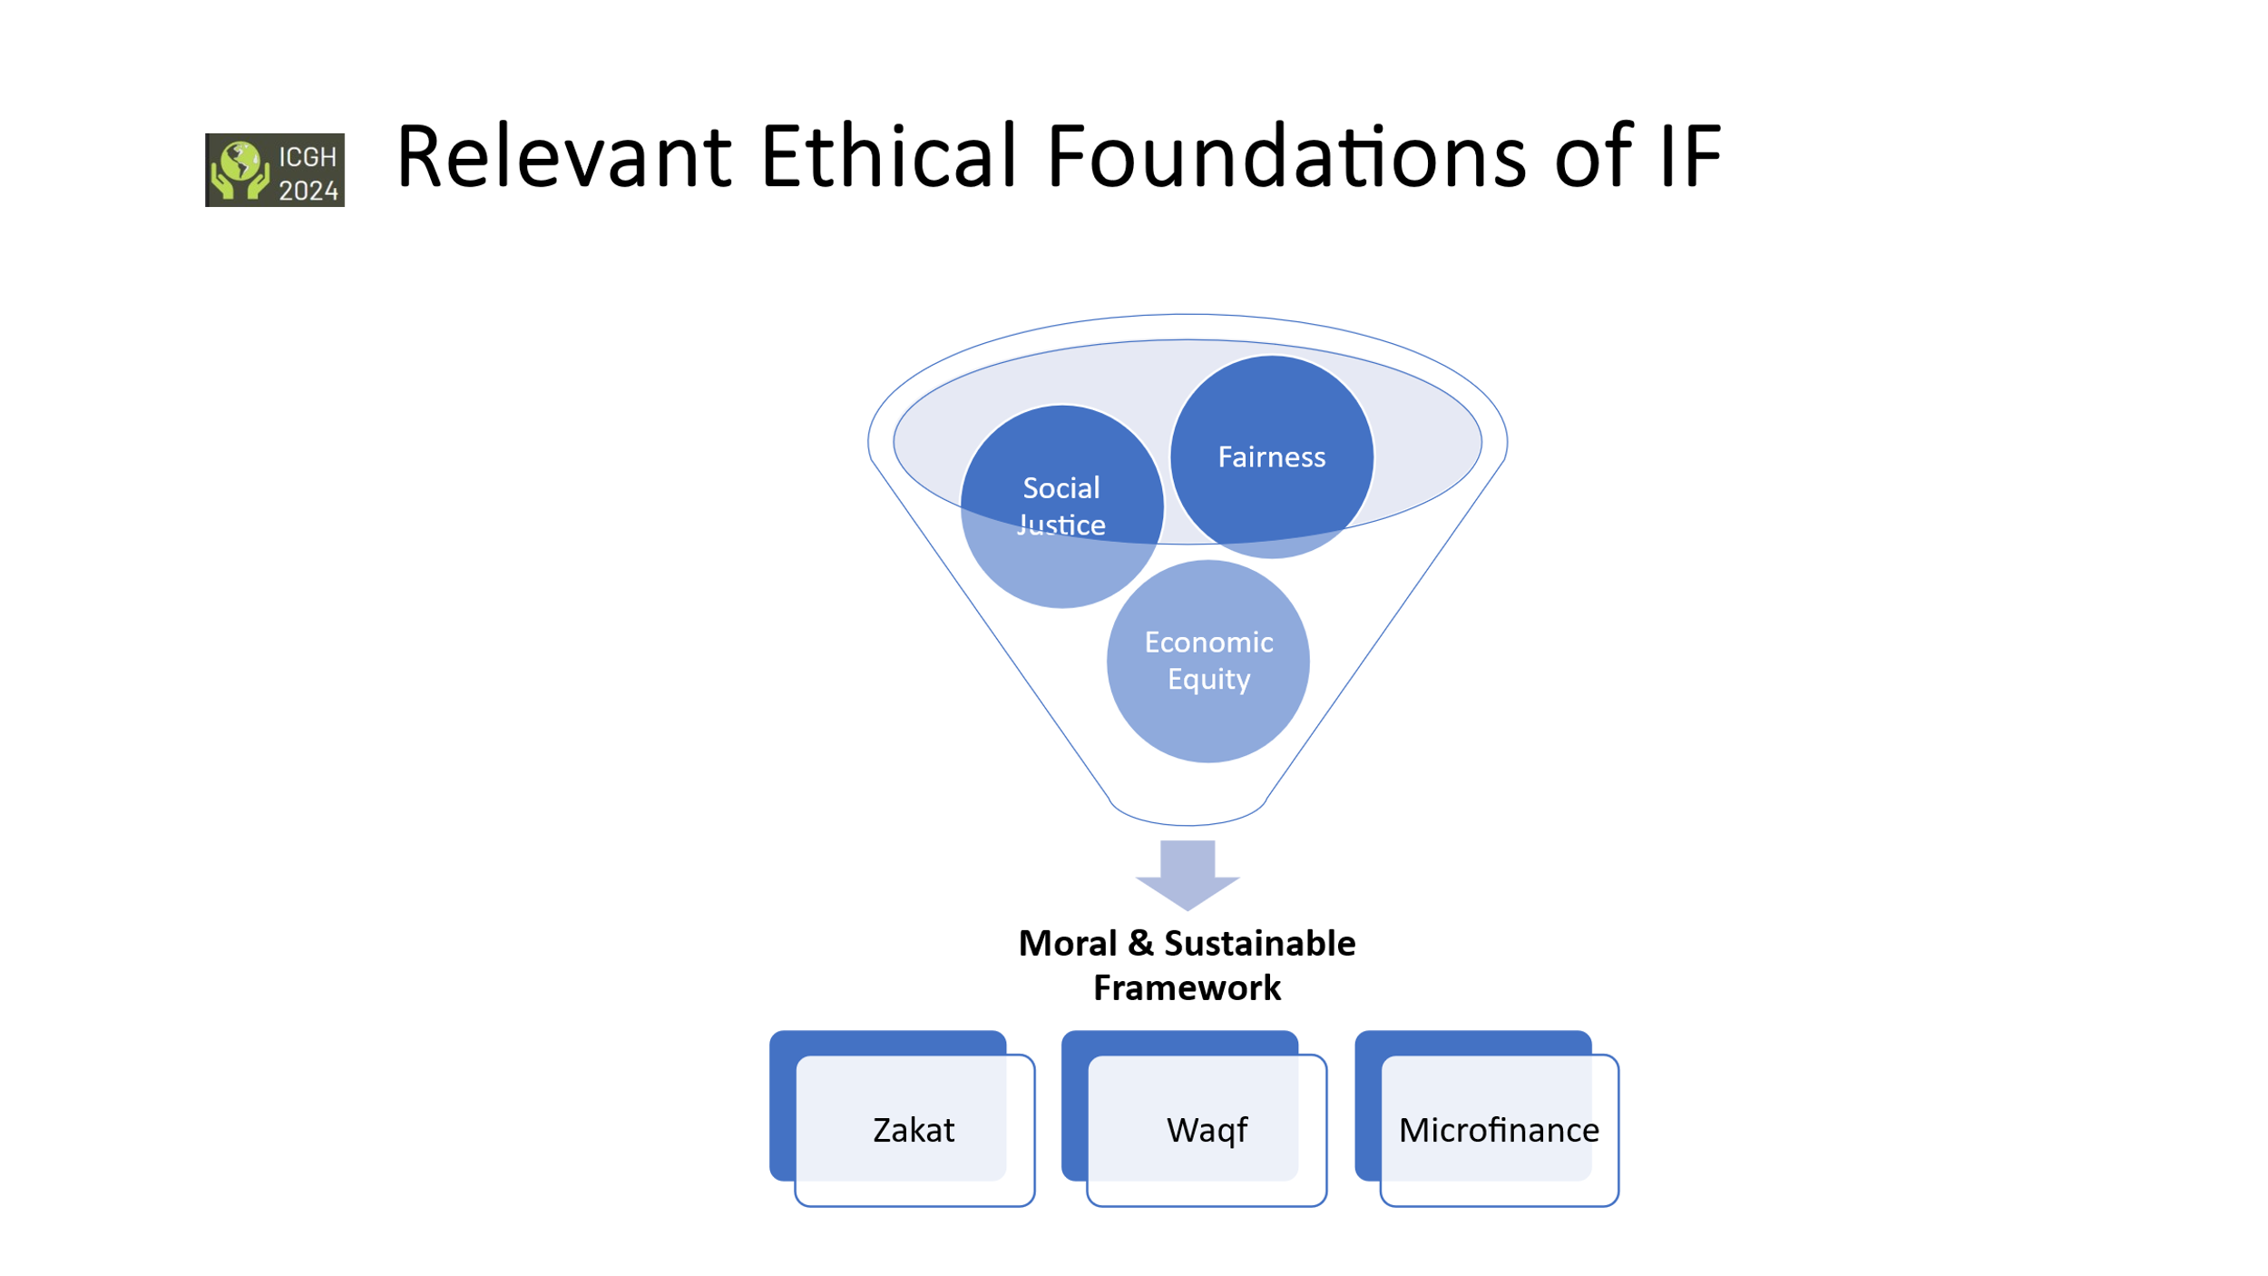

As we have seen, wider income gaps are happening and the uneven distribution of wealth and resources among individuals or groups within a society has been observed especially disparity between the rich and poor. This can lead to social unrest, reduced economic mobility, and weakened social cohesion. It often perpetuates cycles of poverty and limits access to opportunities for disadvantaged groups.

In the today’s economy and financial system these communities in a way systematically isolated or some of them are neglected – preventing them from participating fully in social, economics and political life. The marginalized communities are sometime the victim of ethnicity, religion, gender. This inequity prevent them access to essential resources, opportunities, and representation, often leading to social alienation and economic stagnation.

Addressing these issues requires comprehensive strategies to promote inclusivity, equitable resource distribution, and opportunities for all.

**Relevant Ethical Foundations of IF**

These three ethical principles on which the foundation of Islamic Finance is based in creating a moral and sustainable financial system:

The social justice takes us back to equitable wealth distribution and the elimination of exploitation and poverty. Here we have the opportunity to aligns financial practices with the well-being of society by promoting initiatives like zakat (mandatory almsgiving), waqf (endowments), and microfinance, ensuring that resources are directed toward societal benefit and the upliftment of marginalized groups.

Let’s take an example of waqf, this let alone can take care of ummah is financial disparity if it identified and managed properly. As we have seen there are so many endowments and foundations are being formed recently. The good example of university endowments, they are so rich and run the institution successfully in an independent manner. As our past show that we muslim has such a endowments for example Al Azhar. Today it depend on state funding, its own waqf got demolished or dissolved taken over the by government. In Muslim world almost all universities run by state funding, apparently do not have their own endowment.

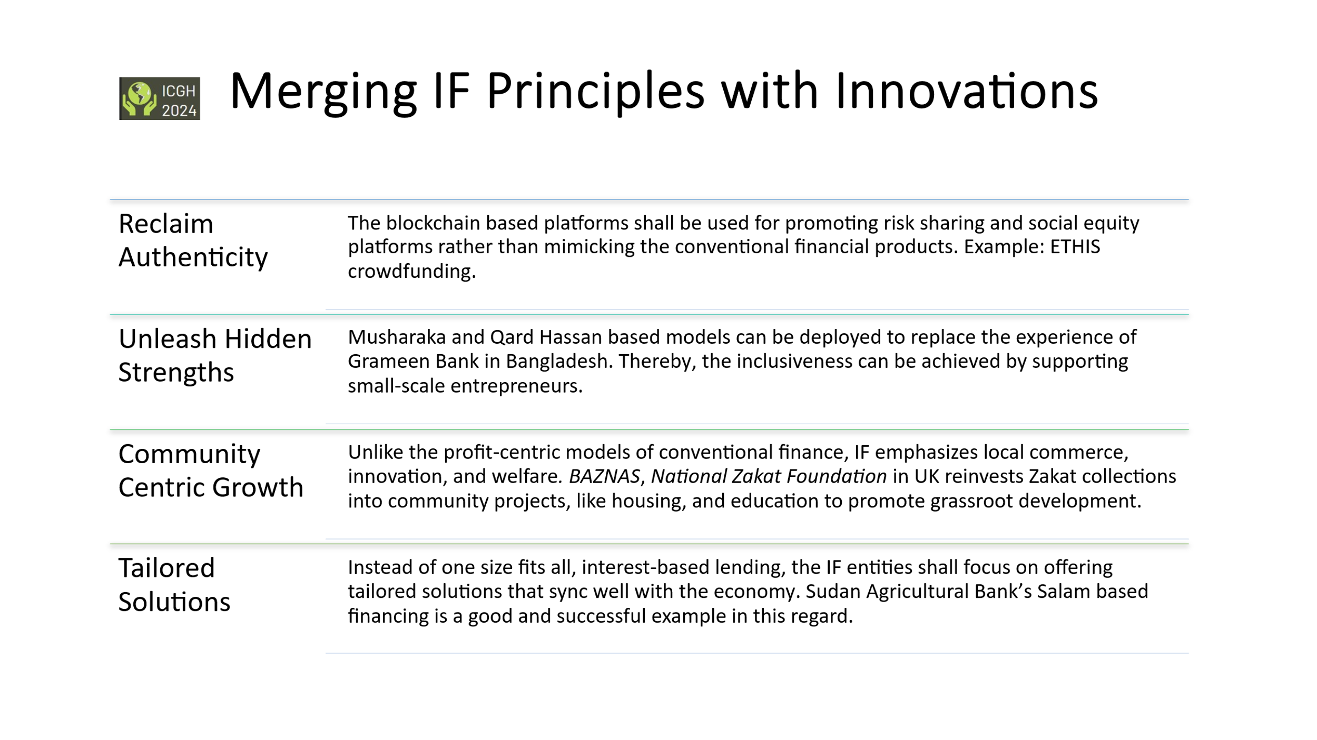Islamic finance prohibits practices like riba (interest) and gharar (excessive uncertainty) to ensure that all parties involved in a transaction are treated equitably. It promotes risk-sharing mechanisms (not risk shifting environment as it is observed in the West). Other instrument employed by IF such as mudarabah (profit-sharing) and musharakah (partnership), where benefits and risks are distributed fairly.

Thus, Islamic finance aims to create a balanced economic system by encouraging ethical investment and redistribution of wealth through charitable mechanisms and prohibition of exploitative practices.

This ethical foundation ensures that Islamic finance serves as a tool for achieving a just, fair, and equitable economic system that is both socially responsible and environmentally sustainable.

**Merging IF Principles with Innovations**

A few days back, on 4th and 5th December 2024, we held our 7th edition of ICIF “*A Rooted Future”* in Doha. We highlighted the importance of merging the timeless principles of Islamic finance with contemporary innovations. This vision reflects a commitment to preserving ethical traditions while embracing tools such as artificial intelligence, blockchain, and fintech. Such integration ensures that Islamic finance remains relevant and impactful in addressing modern challenges.

*Reclaim Authenticity*

When we talk about reclaiming authenticity in Islamic Finance, we are calling for a return to its foundational principles—principles rooted in risk-sharing, fairness, and social equity.

Blockchain-based platforms, for instance, offer us a unique opportunity. Instead of simply mimicking conventional financial products, we should leverage these technologies to promote true risk-sharing and social equity. This is not just an aspiration; it is a tangible opportunity for Islamic Finance to stand out and lead the way in ethical financial innovation.

We already see promising examples at a smaller scale where such innovations are making an impact. Take ETHIS crowdfunding, for instance—a platform that embodies the spirit of Islamic Finance by enabling communities to pool resources and share risks in a truly participatory manner.

This, is the potential we must capitalize on. Let us ensure that Islamic Finance remains true to its values while embracing cutting-edge technologies to drive meaningful and equitable change

*Unleash Hidden Strengths*

As we strive to build a more inclusive and impactful financial system, it is imperative that we unleash the hidden strengths within Islamic Finance. Models like Musharakah and Qard Hassan hold immense potential to transform the lives of those at the grassroots level.

Consider this: these models can be adapted to replicate the incredible success of initiatives like the Grameen Bank in Bangladesh or Akhuwat in Pakistan. By supporting small-scale entrepreneurs and providing them with the resources they need, we can foster a culture of empowerment and financial inclusivity.

This is not just about financial transactions; it is about creating opportunities, building communities, and uplifting those who have been left behind. Islamic Finance has the tools—it’s time to deploy them where they matter most.

*Community Centric Growth*

One of the greatest strengths of Islamic Finance lies in its focus on community-centric growth. Unlike the profit-centric models of conventional finance, Islamic Finance emphasizes the well-being of communities through local commerce, innovation, and welfare.

A shining example of this is the National Zakat Foundation (NZF) in the UK. Through its innovative approach, NZF reinvests Zakat collections into community projects like housing and education, directly addressing the needs of grassroots development.

This model demonstrates the true essence of Islamic Finance—empowering communities, fostering sustainable growth, and ensuring that resources are channeled where they have the greatest impact. It is a reminder that when communities thrive, nations prosper.

*Tailored Solutions*

In the world of finance, one size does not fit all. This is where Islamic Finance has the opportunity to truly shine by offering **tailored solutions** that align with the unique needs of economies and communities.

Rather than relying on standardized, interest-based lending models, Islamic Finance entities can design customized financial products that cater to specific sectors. A great example of this is the Sudan Agricultural Bank, which uses Salam-based financing to support the agricultural sector. This approach not only provides much-needed funding to farmers but also promotes sustainability and economic growth.

By focusing on solutions that sync with the realities of each economy, Islamic Finance can create lasting impact and prove its adaptability to diverse contexts.

**Call for Action**

*Avoid Speculative Financial Instruments*

The global financial crises have repeatedly exposed the vulnerabilities and pitfalls of speculative financing, serving as a stark reminder of the need for stability and real value in financial systems.

Islamic Finance addresses this challenge by emphasizing real asset-backed investments.

A notable example is the DanaInfra Retail Sukuk in Malaysia, which funds critical infrastructure projects such as public transportation systems.

By ensuring that investments are tied to tangible assets, this approach fosters stability, transparency, and long-term economic growth.

Unlike speculative instruments, real asset-backed investments create value that is both sustainable and impactful, aligning perfectly with the ethical principles of Islamic Finance.

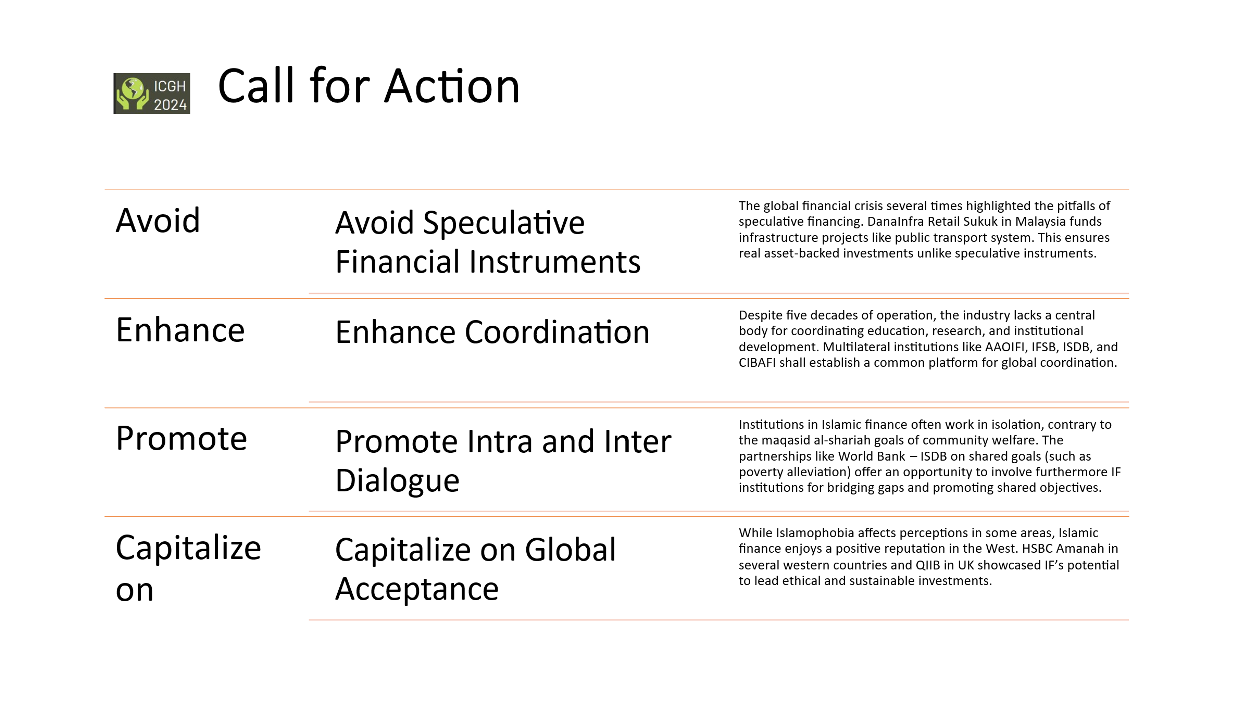

*Need for Global Coordination*

Despite five decades of operation, the Islamic Finance industry still faces a significant gap: the absence of a central body to coordinate education, research, and institutional development. This lack of unified direction hampers the industry’s ability to grow cohesively on a global scale.

To address this, multilateral institutions such as AAOIFI, IFSB, ISDB, and CIBAFI must come together to establish a common platform for global coordination. Such a platform would not only streamline efforts but also foster collaboration, standardization, and innovation across borders.

By working collectively, these institutions can strengthen the industry’s foundation, enhance its credibility, and ensure its continued relevance in addressing global financial challenges.

*Fostering Collaborative Partnerships*

One of the challenges facing the Islamic Finance industry is that many institutions operate in isolation, which runs counter to the maqasid al-shariah—the higher objectives of Shariah, including community welfare and social justice.

However, there are promising examples that showcase the power of collaboration. For instance, the World Bank and ISDB partnership focuses on shared goals such as poverty alleviation, demonstrating how partnerships can amplify impact.

This model provides a valuable opportunity to involve more Islamic Finance institutions in bridging gaps, pooling resources, and working towards shared objectives. Through collaboration, we can align the industry more closely with its ethical foundation and create meaningful, lasting change for communities worldwide.

Promote Islamic Finance: A Positive Force in the West

While Islamophobia continues to affect perceptions in certain areas, it is important to recognize that Islamic Finance enjoys a largely positive reputation in the West. This is because its principles of ethical and sustainable investment resonate strongly with global values of responsibility and fairness.

Institutions like HSBC Amanah, operating in several Western countries, and QIIB in the UK, have demonstrated the potential of Islamic Finance to lead the way in ethical financial practices. These examples highlight how Islamic Finance can bridge gaps and foster mutual understanding, all while contributing to sustainable development.

This positive reception provides an opportunity for the industry to expand its influence and further showcase its unique value proposition as a global leader in ethical finance.

**Conclusion**

To fully realize the transformative potential of Islamic Finance, regulatory bodies must take the lead in encouraging institutions to reconceptualize their products. This involves aligning financial offerings more closely with the core principles of Islamic Finance—principles that aim to minimize income inequality and include marginalized communities in economic growth.

By reimagining Islamic financial products, institutions can go beyond mere compliance and actively work toward reducing the income gap. This approach not only reinforces the ethical foundation of Islamic Finance but also ensures its role as a force for positive social change.

It is time for the industry to move from traditional frameworks to more inclusive and impactful solutions, guided by proactive regulatory leadership.

Ladies and gentlemen, Maqasid Al-Shari’ah: A Timeless Framework

As we all know the scope of Maqasid Al-Shari’ah extends far beyond the sustainable objectives outlined in frameworks like the Sustainable Development Goals (SDGs) and Environmental, Social, and Governance (ESG) principles. While these modern frameworks address crucial global challenges, Maqasid Al-Shari’ah offers a timeless and comprehensive foundation that enriches and guides Islamic Finance.

By emphasizing justice, equity, and human welfare, Maqasid Al-Shari’ah provides enduring principles that are not limited by time or context. It allows Islamic Finance to not only align with contemporary sustainability goals but also to elevate them by embedding deeper ethical and moral considerations into financial systems.

This is the unique contribution of Islamic Finance—a system rooted in principles that are both universal and everlasting.

In conclusion, Islamic finance holds immense promise—not as an alternative but as a leader in crafting a just and equitable global financial order. By building on its ethical foundations and embracing innovation, it can pave the way for a future that is inclusive, sustainable, and morally grounded.